

**NAME OF THE PROJECT**

PROJECT HOUSING

Submitted by:

Dharambir Mahto

**ACKNOWLEDGMENT**

This is to acknowledge that I have done all my work with great sincerity and enthusiasm. I would like to thank madam khushboo garg who has given me the opportunity to work on Rating Prediction Project. While working on the project I experienced lot of problems and hurdles but I am glad that I completed my project on time. In this project I have learned a lot of things and I think that this project will prove to bring a breakthrough in my future career.

**Problem Statement—**

Houses are one of the necessary need of each and every person around the globe and therefore housing and real estate market is one of the markets which is one of the major contributors in the world’s economy. It is a very large market and there are various companies working in the domain. Data science comes as a very important tool to solve problems in the domain to help the companies increase their overall revenue, profits, improving their marketing strategies and focusing on changing trends in house sales and purchases. Predictive modelling, Market mix modelling, recommendation systems are some of the machine learning techniques used for achieving the business goals for housing companies. Our problem is related to one such housing company.

**Abstract—**

With the explosion of online user reviews, review rating prediction has become a research focus in natural language processing. Existing review rating prediction methods only use a single model to capture the sentiments of review texts, ignoring users who express the sentiment and products that are evaluated, both of which have great inﬂuences on review rating prediction. In order to solve the issue, we propose a review rating prediction method based on user context and product context by incorporating user information and product information into review texts. Our method ﬁrstly models the user context information of reviews, and then models the product context information of reviews. Finally, a review rating prediction method that is based on user context is proposed. A user-speciﬁc review rating prediction model, which represents the user’s personalized sentiment information, and can be learned from training data of an individual user.

**INTRODUCTION :-**

In this project, we will develop and evaluate the performance and the predictive power of a model trained and tested on data collected from houses in Boston’s suburbs.

Once we get a good fit, we will use this model to predict the monetary value of a house located at the Boston’s area.

A model like this would be very valuable for a real state agent who could make use of the information provided in a daily basis.

* **Data Gathering:-**

The dataset used in this project are train data and test data. Train data has 1164 rows and 81 columns and test data has 737 rows and 80 columns.

The features can be summarized as follows:

MSSubClass: Identifies the type of dwelling involved in the sale.

20 1-STORY 1946 & NEWER ALL STYLES

30 1-STORY 1945 & OLDER

40 1-STORY W/FINISHED ATTIC ALL AGES

45 1-1/2 STORY - UNFINISHED ALL AGES

50 1-1/2 STORY FINISHED ALL AGES

60 2-STORY 1946 & NEWER

70 2-STORY 1945 & OLDER

75 2-1/2 STORY ALL AGES

80 SPLIT OR MULTI-LEVEL

85 SPLIT FOYER

90 DUPLEX - ALL STYLES AND AGES

120 1-STORY PUD (Planned Unit Development) - 1946 & NEWER

150 1-1/2 STORY PUD - ALL AGES

160 2-STORY PUD - 1946 & NEWER

180 PUD - MULTILEVEL - INCL SPLIT LEV/FOYER

190 2 FAMILY CONVERSION - ALL STYLES AND AGES

MSZoning: Identifies the general zoning classification of the sale.

A Agriculture

C Commercial

FV Floating Village Residential

I Industrial

RH Residential High Density

RL Residential Low Density

RP Residential Low Density Park

RM Residential Medium Density

LotFrontage: Linear feet of street connected to property

LotArea: Lot size in square feet

Street: Type of road access to property

Grvl Gravel

Pave Paved

Alley: Type of alley access to property

Grvl Gravel

Pave Paved

NA No alley access

LotShape: General shape of property

Reg Regular

IR1 Slightly irregular

IR2 Moderately Irregular

IR3 Irregular

LandContour: Flatness of the property

Lvl Near Flat/Level

Bnk Banked - Quick and significant rise from street grade to building

HLS Hillside - Significant slope from side to side

Low Depression

Utilities: Type of utilities available

AllPub All public Utilities (E,G,W,& S)

NoSewr Electricity, Gas, and Water (Septic Tank)

NoSeWa Electricity and Gas Only

ELO Electricity only

LotConfig: Lot configuration

Inside Inside lot

Corner Corner lot

CulDSac Cul-de-sac

FR2 Frontage on 2 sides of property

FR3 Frontage on 3 sides of property

LandSlope: Slope of property

Gtl Gentle slope

Mod Moderate Slope

Sev Severe Slope

Neighborhood: Physical locations within Ames city limits

Blmngtn Bloomington Heights

Blueste Bluestem

BrDale Briardale

BrkSide Brookside

ClearCr Clear Creek

CollgCr College Creek

Crawfor Crawford

Edwards Edwards

Gilbert Gilbert

IDOTRR Iowa DOT and Rail Road

MeadowV Meadow Village

Mitchel Mitchell

Names North Ames

NoRidge Northridge

NPkVill Northpark Villa

NridgHt Northridge Heights

NWAmes Northwest Ames

OldTown Old Town

SWISU South & West of Iowa State University

Sawyer Sawyer

SawyerW Sawyer West

Somerst Somerset

StoneBr Stone Brook

Timber Timberland

Veenker Veenker

Condition1: Proximity to various conditions

Artery Adjacent to arterial street

Feedr Adjacent to feeder street

Norm Normal

RRNn Within 200' of North-South Railroad

RRAn Adjacent to North-South Railroad

PosN Near positive off-site feature--park, greenbelt, etc.

PosA Adjacent to postive off-site feature

RRNe Within 200' of East-West Railroad

RRAe Adjacent to East-West Railroad

Condition2: Proximity to various conditions (if more than one is present)

Artery Adjacent to arterial street

Feedr Adjacent to feeder street

Norm Normal

RRNn Within 200' of North-South Railroad

RRAn Adjacent to North-South Railroad

PosN Near positive off-site feature--park, greenbelt, etc.

PosA Adjacent to postive off-site feature

RRNe Within 200' of East-West Railroad

RRAe Adjacent to East-West Railroad

BldgType: Type of dwelling

1Fam Single-family Detached

2FmCon Two-family Conversion; originally built as one-family dwelling

Duplx Duplex

TwnhsE Townhouse End Unit

TwnhsI Townhouse Inside Unit

HouseStyle: Style of dwelling

1Story One story

1.5Fin One and one-half story: 2nd level finished

1.5Unf One and one-half story: 2nd level unfinished

2Story Two story

2.5Fin Two and one-half story: 2nd level finished

2.5Unf Two and one-half story: 2nd level unfinished

SFoyer Split Foyer

SLvl Split Level

OverallQual: Rates the overall material and finish of the house

10 Very Excellent

9 Excellent

8 Very Good

7 Good

6 Above Average

5 Average

4 Below Average

3 Fair

2 Poor

1 Very Poor

OverallCond: Rates the overall condition of the house

10 Very Excellent

9 Excellent

8 Very Good

7 Good

6 Above Average

5 Average

4 Below Average

3 Fair

2 Poor

1 Very Poor

YearBuilt: Original construction date

YearRemodAdd: Remodel date (same as construction date if no remodeling or additions)

RoofStyle: Type of roof

Flat Flat

Gable Gable

Gambrel Gabrel (Barn)

Hip Hip

Mansard Mansard

Shed Shed

RoofMatl: Roof material

ClyTile Clay or Tile

CompShg Standard (Composite) Shingle

Membran Membrane

Metal Metal

Roll Roll

Tar&Grv Gravel & Tar

WdShake Wood Shakes

WdShngl Wood Shingles

Exterior1st: Exterior covering on house

AsbShng Asbestos Shingles

AsphShn Asphalt Shingles

BrkComm Brick Common

BrkFace Brick Face

CBlock Cinder Block

CemntBd Cement Board

HdBoard Hard Board

ImStucc Imitation Stucco

MetalSd Metal Siding

Other Other

Plywood Plywood

PreCast PreCast

Stone Stone

Stucco Stucco

VinylSd Vinyl Siding

Wd Sdng Wood Siding

WdShing Wood Shingles

Exterior2nd: Exterior covering on house (if more than one material)

AsbShng Asbestos Shingles

AsphShn Asphalt Shingles

BrkComm Brick Common

BrkFace Brick Face

CBlock Cinder Block

CemntBd Cement Board

HdBoard Hard Board

ImStucc Imitation Stucco

MetalSd Metal Siding

Other Other

Plywood Plywood

PreCast PreCast

Stone Stone

Stucco Stucco

VinylSd Vinyl Siding

Wd Sdng Wood Siding

WdShing Wood Shingles

MasVnrType: Masonry veneer type

BrkCmn Brick Common

BrkFace Brick Face

CBlock Cinder Block

None None

Stone Stone

MasVnrArea: Masonry veneer area in square feet

ExterQual: Evaluates the quality of the material on the exterior

Ex Excellent

Gd Good

TA Average/Typical

Fa Fair

Po Poor

ExterCond: Evaluates the present condition of the material on the exterior

Ex Excellent

Gd Good

TA Average/Typical

Fa Fair

Po Poor

Foundation: Type of foundation

BrkTil Brick & Tile

CBlock Cinder Block

PConc Poured Contrete

Slab Slab

Stone Stone

Wood Wood

BsmtQual: Evaluates the height of the basement

Ex Excellent (100+ inches)

Gd Good (90-99 inches)

TA Typical (80-89 inches)

Fa Fair (70-79 inches)

Po Poor (<70 inches

NA No Basement

BsmtCond: Evaluates the general condition of the basement

Ex Excellent

Gd Good

TA Typical - slight dampness allowed

Fa Fair - dampness or some cracking or settling

Po Poor - Severe cracking, settling, or wetness

NA No Basement

BsmtExposure: Refers to walkout or garden level walls

Gd Good Exposure

Av Average Exposure (split levels or foyers typically score average or above)

Mn Mimimum Exposure

No No Exposure

NA No Basement

BsmtFinType1: Rating of basement finished area

GLQ Good Living Quarters

ALQ Average Living Quarters

BLQ Below Average Living Quarters

Rec Average Rec Room

LwQ Low Quality

Unf Unfinshed

NA No Basement

BsmtFinSF1: Type 1 finished square feet

BsmtFinType2: Rating of basement finished area (if multiple types)

GLQ Good Living Quarters

ALQ Average Living Quarters

BLQ Below Average Living Quarters

Rec Average Rec Room

LwQ Low Quality

Unf Unfinshed

NA No Basement

BsmtFinSF2: Type 2 finished square feet

BsmtUnfSF: Unfinished square feet of basement area

TotalBsmtSF: Total square feet of basement area

Heating: Type of heating

Floor Floor Furnace

GasA Gas forced warm air furnace

GasW Gas hot water or steam heat

Grav Gravity furnace

OthW Hot water or steam heat other than gas

Wall Wall furnace

HeatingQC: Heating quality and condition

Ex Excellent

Gd Good

TA Average/Typical

Fa Fair

Po Poor

CentralAir: Central air conditioning

N No

Y Yes

Electrical: Electrical system

SBrkr Standard Circuit Breakers & Romex

FuseA Fuse Box over 60 AMP and all Romex wiring (Average)

FuseF 60 AMP Fuse Box and mostly Romex wiring (Fair)

FuseP 60 AMP Fuse Box and mostly knob & tube wiring (poor)

Mix Mixed

1stFlrSF: First Floor square feet

2ndFlrSF: Second floor square feet

LowQualFinSF: Low quality finished square feet (all floors)

GrLivArea: Above grade (ground) living area square feet

BsmtFullBath: Basement full bathrooms

BsmtHalfBath: Basement half bathrooms

FullBath: Full bathrooms above grade

HalfBath: Half baths above grade

Bedroom: Bedrooms above grade (does NOT include basement bedrooms)

Kitchen: Kitchens above grade

KitchenQual: Kitchen quality

Ex Excellent

Gd Good

TA Typical/Average

Fa Fair

Po Poor

TotRmsAbvGrd: Total rooms above grade (does not include bathrooms)

Functional: Home functionality (Assume typical unless deductions are warranted)

Typ Typical Functionality

Min1 Minor Deductions 1

Min2 Minor Deductions 2

Mod Moderate Deductions

Maj1 Major Deductions 1

Maj2 Major Deductions 2

Sev Severely Damaged

Sal Salvage only

Fireplaces: Number of fireplaces

FireplaceQu: Fireplace quality

Ex Excellent - Exceptional Masonry Fireplace

Gd Good - Masonry Fireplace in main level

TA Average - Prefabricated Fireplace in main living area or Masonry Fireplace in basement

Fa Fair - Prefabricated Fireplace in basement

Po Poor - Ben Franklin Stove

NA No Fireplace

GarageType: Garage location

2Types More than one type of garage

Attchd Attached to home

Basment Basement Garage

BuiltIn Built-In (Garage part of house - typically has room above garage)

CarPort Car Port

Detchd Detached from home

NA No Garage

GarageYrBlt: Year garage was built

GarageFinish: Interior finish of the garage

Fin Finished

RFn Rough Finished

Unf Unfinished

NA No Garage

GarageCars: Size of garage in car capacity

GarageArea: Size of garage in square feet

GarageQual: Garage quality

Ex Excellent

Gd Good

TA Typical/Average

Fa Fair

Po Poor

NA No Garage

GarageCond: Garage condition

Ex Excellent

Gd Good

TA Typical/Average

Fa Fair

Po Poor

NA No Garage

PavedDrive: Paved driveway

Y Paved

P Partial Pavement

N Dirt/Gravel

WoodDeckSF: Wood deck area in square feet

OpenPorchSF: Open porch area in square feet

EnclosedPorch: Enclosed porch area in square feet

3SsnPorch: Three season porch area in square feet

ScreenPorch: Screen porch area in square feet

PoolArea: Pool area in square feet

PoolQC: Pool quality

Ex Excellent

Gd Good

TA Average/Typical

Fa Fair

NA No Pool

Fence: Fence quality

GdPrv Good Privacy

MnPrv Minimum Privacy

GdWo Good Wood

MnWw Minimum Wood/Wire

NA No Fence

MiscFeature: Miscellaneous feature not covered in other categories

Elev Elevator

Gar2 2nd Garage (if not described in garage section)

Othr Other

Shed Shed (over 100 SF)

TenC Tennis Court

NA None

MiscVal: $Value of miscellaneous feature

MoSold: Month Sold (MM)

YrSold: Year Sold (YYYY)

SaleType: Type of sale

WD Warranty Deed - Conventional

CWD Warranty Deed - Cash

VWD Warranty Deed - VA Loan

New Home just constructed and sold

COD Court Officer Deed/Estate

Con Contract 15% Down payment regular terms

ConLw Contract Low Down payment and low interest

ConLI Contract Low Interest

ConLD Contract Low Down

Oth Other

SaleCondition: Condition of sale

Normal Normal Sale

Abnorml Abnormal Sale - trade, foreclosure, short sale

AdjLand Adjoining Land Purchase

Alloca Allocation - two linked properties with separate deeds, typically condo with a garage unit

Family Sale between family members

Partial Home was not completed when last assessed (associated with New Homes)

* **Data Cleaning:-**

This step, also known as pre-processing, is aimed at cleaning the data. Indeed, text reviews contain unnecessary and redundant characters and have to be normalized. More precisely, the objective of the data cleaning consists in:

a) removed null values

b) removed skewness

c) removed outliers

d) used label encoder to encode categorical variables

e) also used standard scalar

* Hardware and Software Requirements and Tools Used:-

1. **Hardware Required:-**

Processor – intel core i3 used to process the software faster but intel i5 or i7 is recommended.

RAM – 4 GB DDR :- used to run software run faster.

1TB Hard Disk(HDD) :- used for the storage but its always recommended to use SSD.

**B)Software Required:-**

1)Anaconda :- anaconda is a software which contains lots of libraries and software in itself like jupyter notebook, spyder, pycharm etc.

2)jupyter notebook /spyder:- Jupyter Notebook is a software to write codes efficiently and effectively and it is user friendly.

**C)Tools:-**

1)Matplot library :- Matplotlib is a cross-platform, data

visualization and graphical plotting library for Python

and its numerical extension NumPy.

2)Pandas library:- pandas library is used for data

manipulation and analysis.

3)Numpy library:- NumPy is a Python library used for working with arrays. It also has functions for working in domain of linear algebra, fourier transform, and matrices.

4)Sklearn library:- Scikit-learn (Sklearn) is the most useful and robust library for machine learning in Python. It provides a selection of efficient tools for machine learning and statistical modeling including classification, regression, clustering and dimensionality reduction via a consistence interface in Python.

* **Visualization**

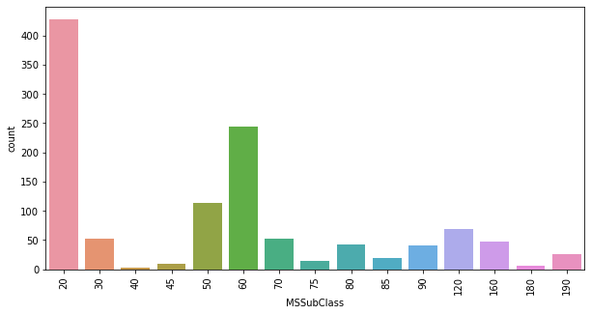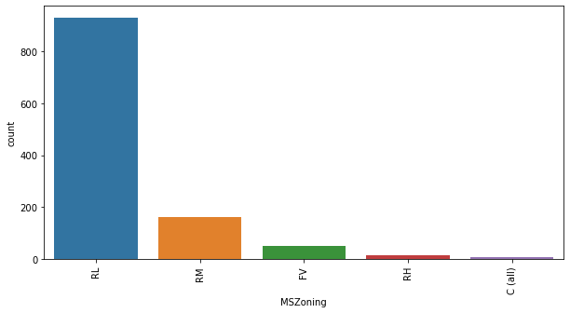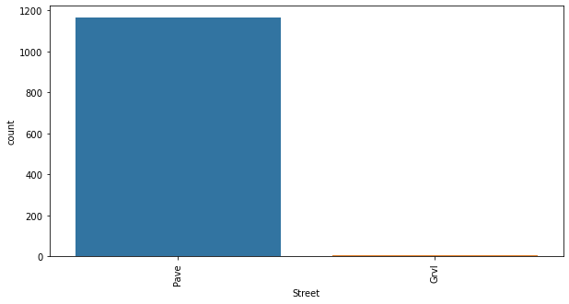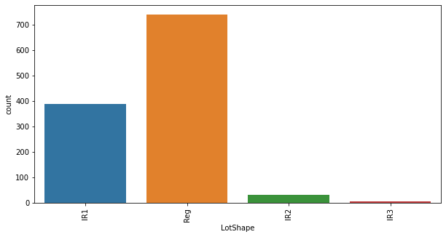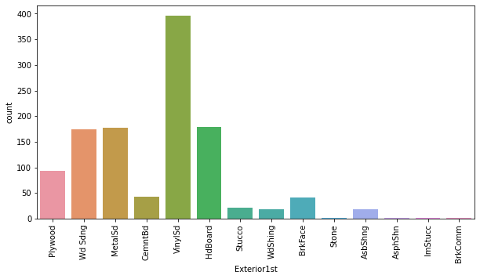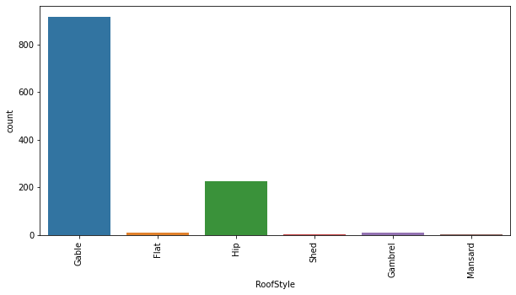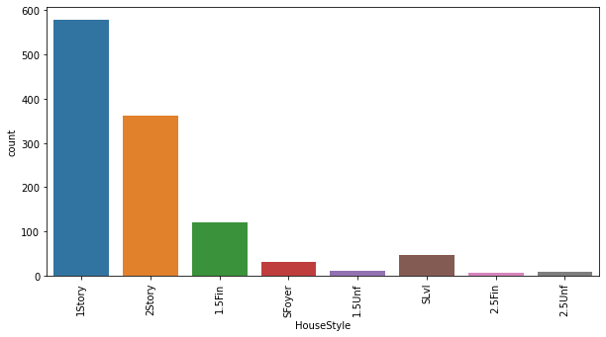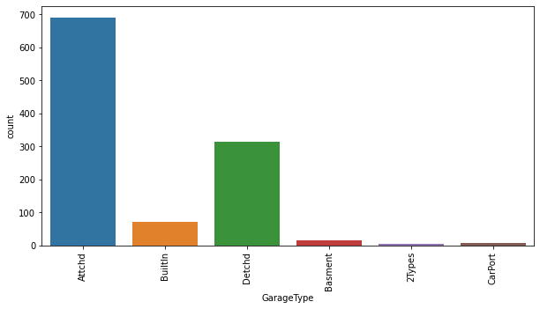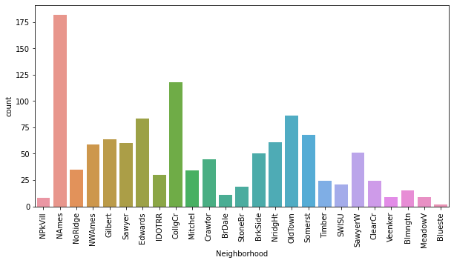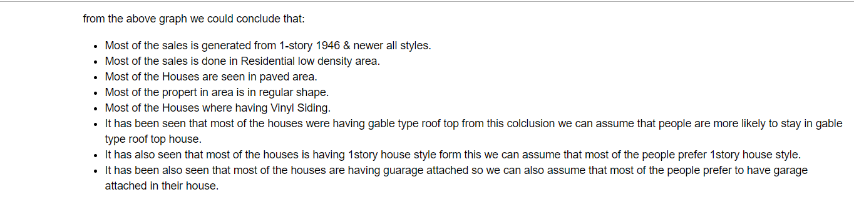

**Developing a Model: -**

In this second section of the project, we will develop the tools and techniques necessary for a model to make a prediction. Being able to make accurate evaluations of each model’s performance through the use of these tools and techniques helps to reinforce greatly the confidence in the predictions.

**Defining a Performace Metric**

It is difficult to measure the quality of a given model without quantifying its performance on the training and testing. This is typically done using some type of performance metric, whether it is through calculating some type of error, the goodness of fit, or some other useful measurement.

For this project, we will calculate the coefficient of determination, R², to quantify the model’s performance. The coefficient of determination for a model is a useful statistic in regression analysis, as it often describes how “good” that model is at making predictions.

The values for R² range from 0 to 1, which captures the percentage of squared correlation between the predicted and actual values of the target variable.

A model with an R² of 0 is no better than a model that always predicts the mean of the target variable.

Whereas a model with an R² of 1 perfectly predicts the target variable.

Any value between 0 and 1 indicates what percentage of the target variable, using this model, can be explained by the features.

A model can be given a negative R2 as well, which indicates that the model is arbitrarily worse than one that always predicts the mean of the target variable.

* **Shuffle and Split Data: -**

For this section we will take the Boston housing dataset and split the data into training and testing subsets. Typically, the data is also shuffled into a random order when creating the training and testing subsets to remove any bias in the ordering of the dataset.

* **Training and Testing: -**

What is the benefit to splitting a dataset into some ratio of training and testing subsets for a learning algorithm?

It is useful to evaluate our model once it is trained. We want to know if it has learned properly from a training split of the data. There can be 3 different situations:

1) The model didn´t learn well on the data, and can’t predict even the outcomes of the training set, this is called underfitting and it is caused because a high bias.

2) The model learn too well the training data, up to the point that it memorized it and is not able to generalize on new data, this is called overfitting, it is caused because high variance.

3) The model just had the right balance between bias and variance, it learned well and is able predict correctly the outcomes on new data.

* **Conclusion:-**

Throughout this article we made a machine learning regression project from end-to-end and we learned and obtained several insights about regression models and how they are developed.

This was the first of the machine learning projects that will be developed on this series. If you liked it, stay tuned for the next article! Which will be an introduction to the theory and concepts regarding to classification algorithms.